Appendix 1: Student Declaration re ORIGINALITY AND AUTHORSHIP OF WORK SUBMITTED IN THE ALTERNATIVE TERMINAL ASSESSMENT

Alternative Terminal Assignments Document Submission Cover Sheet

Please ensure that you complete all relevant sections below and that you make this the first page of your Alternative Terminal Assignments submission.
For submission, you are required to put all aspects of the Alternative Terminal Assignments into one document, including the cover sheer below and then to submit the assignment, on Moodle in the relevant module location.
The assignment must be completed on or before the designated submission date and time. Students are recommended to keep a copy of the assignment, as submitted.
Please complete the following, in advance of submission.
If for some reason you cannot complete this form to attach to your assessment, please hand write the details, photograph and upload to Moodle.
Student Number  A00266219 | Programme Title:  Cloud Computing
Programme Year:  3 |  | Module Title:  Web Development 3
Lecturer Name:
James Byrne
Number of questions answered:
3
Please list the Question numbers attempted:
1,3,4
Declaration of Authenticity:
By uploading this document, I confirm that the attached alternative terminal assignment is original and represents all my own work.

Q1. (a)
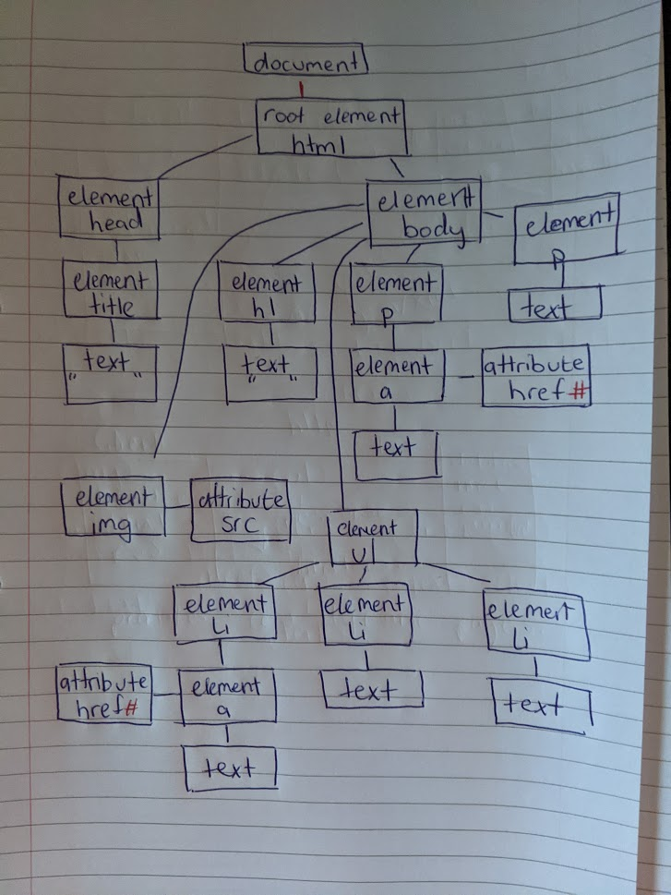
Document – This is the node which contains the whole document, it is the beginning of the DOM where everything else stems therefore it’s the root. This is the node in the document that contains all the other elements such as the html element.
Text – It is the plain text in the document, it can have no children and it’s the lowest form of node. An example in the html document would be the text in the paragraph. “It contains well written, well thought articles”
Attr – This type of node that contains the attributes of selected elements. The alt in the image is an attribute node, the hrefs are also attribute nodes. “images/banner.jpg”, is the src node in the image element.

Q1. (b)
The value logged in the console would be CSS. The variable named “content” is an array with the collection of nodes that have one of their tags as a list item / “li”. The text variable returns the first child of the object at position 1 in the array. When printing it gets the nodeValue which returns a string CSS.
Q1. (c)
The value printed from the code would be #. QuerySelectorAll returns an array of objects within the tag “ul”, the resulting array contains the first element inside the list. With the “first” keyword the array will always only have 1 object which is the first one which meets the condition. We then use getAttribute to select the value of the href in the object which is a #.
Q1. (d)
Class base languages separate classes based on the methods and variables they contain while a prototype-based language contains only objects which then inherit or change other objects. When cloning an object one can essentially extend this new cloned object without having to make a new class or prototype like you would have to in a class-based language like Java. If you create an object based on another it will inherit all the other methods from the first. With this structure you can also add methods to the prototype, and it will be accessible by all objects of the same type. Likewise deleting methods from the prototype removes it from all objects.
function Student(score,name) {
this.score = score
this.name = name
}
Student.prototype.getScore = function getScore() {
console.log("Score is: " + this.score)
}
let michael = new Student("87","Michael")
let john = new michael.constructor('56','John')

michael.__proto__.getName = function() {
console.log(this.name)
}
michael.getScore();
john.getScore();
john.getName();
michael.getName();

In this example John practically extends Evan using its constructor. I added a getScore method to the prototype of the object evan which in turn adds it to michael. In java it is not possible to add methods in this way because it app has to be added in the original class. In javascript the object Michael isn’t an instance of the student object it is its own self contained object which methods, variables can be added and removed.

class person {
private int score;

public person(int score)
{
this.score = score;
}

public int getScore()
{
return this.score;
}

public static void main (String [] args)
{
person p = new person(88);
p.getScore();
}
}

In Java when creating objects, you are limited by how the class is defined. This person object created can only have the variables in the class and the methods there too, it is just an instance of the person class. All person objects all contain the same information and cannot be extended without a whole new class being created and the type of the new class wouldn’t be person it would have to have a different name. Classes in java are basically formats or a blueprint that the instance objects have to follow. While JavaScript there is no one blueprint as they are all objects and can be extended as you like.
Q3. (a)
Safe methods are ones that can be called multiple times without effecting anything, they don’t alter anything just return items. Examples are HEAD, OPTIONS and GET. They do not update anything on the server while unsafe methods such as DELETE and UPDATE change things by removing, adding or updating. These cannot be called multiple times because they make changes, for example you can use GET to pull down data repeatedly but once you DELETE an item once it doesn’t exist so it can’t be used in the same context again. Another example using POST to add a new item, if you send that over and over multiple pieces of identical data will be sent to the database causing unnecessary duplicates.
Q3. (b)
A rich internet application is an application that runs in the browser and has all the functionality a normal desktop application would have. RIA’s use technology to communicate with servers that process information, Ajax is used to dynamically update the page without the user having to fully reload the page. They can be used on a multitude of devices while keeping the same functionality, for example the same website can be opened on a phone and have all the same features. The interface updates in incremental pieces with Ajax based on the user’s interaction with the page such as clicking buttons etc. The server in the background handles all the information, the application can send HTTP requests and receive information back from a database through the server seamlessly.
Rich Web Applications
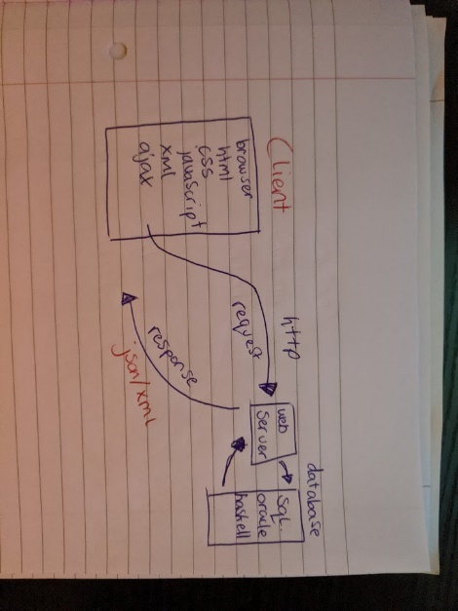
An advantage of using an RIA is that they are generally user friendly, they are intuitive and because they can viewed on many devices they aren’t hard to get used to. Classic web application’s used to just send the whole html page along with javascript and css to the client which means the client is waiting for the information to be downloaded because they can continue using the app while with a RIA the client can still interact with the application because only small pieces are gathered at a time and the whole page doesn’t have to load. The last main advantage is that the application can basically get information anywhere and display it, it can pull information from anywhere and not all the information has to be stored in the one place.
Classic Web Application
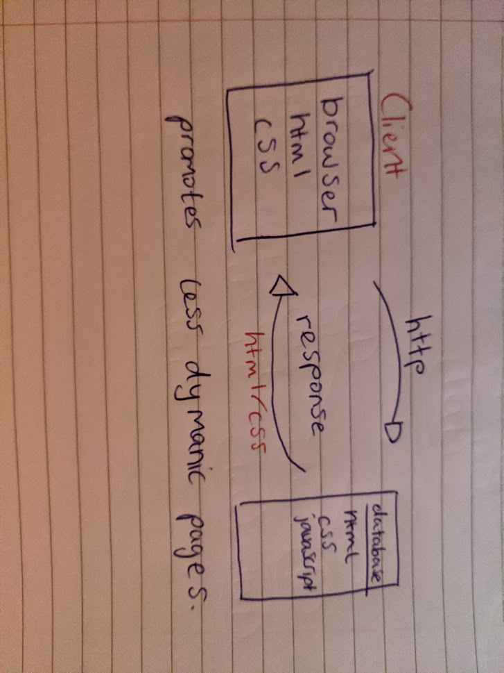
Q3. (c)
(i)
REST is an architectural style. A RESTful API would refer to an application that gives everything a URI and implements the CRUD actions of get, put, post and delete. These methods are how the user interacts with the service. The difference between REST and other services is that it is intuitive, and it uses meaningful names for all its resources. HTTP is generally the backbone of how the API interacts with a database or its resources. The client in a RESTful API interacts through a web server which is where all the requests are handled and where the responses are sent from. The difference between this and another application is how the user interacts with it, http commands are sent by the client and dealt with on the web server, the user has a set of pre-defined commands that they have to use.
(ii)
In a rest API resources can be represented by a URI which is a uniform resource identifier or by a URL which is uniform resource locator. Which ever is used it must be unique for it to be restful, every resource should be distinguishable from any other by this. It doesn’t matter what the resource is or what format it is.
(iii)
Action | HTTP Method | Example URI
Return All pages | GET | /
Return one page based on its id | GET | /content/1
Create a new page | POST | /content
Update a page | PUT | /content/51
Delete a page | DELETE | /content/22
Search for pages based on page title | GET | /content/search/page-title
Q4. (a)
require_once() and include_once() both insert the file in the brackets and run it, they both make sure the file is only inserted once. If the file in the parenthesis can’t be found the require once will crash and not continue while include will give an error but continue running. When connecting to a database you will need all your files so if one is missing like a config file you would want the program to crash and not continue running if it doesn’t connect.
Q4. (b)
The output of the code is 50. The keyword global changes the reference from num1 it the local sense in the function to the global version of it. $num2 in the function refers to the 25 that is given as the input to the function, there is still a global variable that is called num2 as well that is 35. So when creating num3 it uses the global num1 and the input into the function num2 which is 25 + 25 = 50.
Q4. (c)
(i)
Post.
The file that has a max limit of 5mb would not fit in a GET request which has a size limit of a maximum of around 8kb, it would fail to send otherwise or force the data to fit which means data loss. Using put also doesn’t put any information in the URL so the user’s email is hidden, the page also isn’t cached when using PUT.
(ii)
<?php
$full_name = $_POST['full-name'];
$age = $_POST['age'];
$email = $_POST['email'];

if(!is_numeric($age) || !ctype_alpha($full_name))
{
die();
}
?>
<html>
<body>
<table>
<tr>
<td>Name</td>
<td>Age</td>
<td>Email</td>
</tr>
<tr>
<td><?php echo $full_name?></td>
<td><?php echo $age?></td>
<td><?php echo $email?></td>
</tr>
</table>
</body>
</html>

Q4. (d)
<?php
$array = array(
"Home" => "/",
"About us" => "/about-us",
"Services" => "/services",
"Contact us" => "contact-us",
);

function createMenu()
{
$menu = "";
global $array;

foreach ($array as $key => $value) {
$menu.= "<li><a href='{$value}'>{$key}</li>";
}
return $menu;
}

?>

<html>
<body>
<ul>
<?php echo createMenu() ?></br>
</ul>
</body>
</html>

